The process from Need Validation to tendering to invoice processing is conducted over various IT platforms which do not communicate with each other thereby lacking end to end visibility
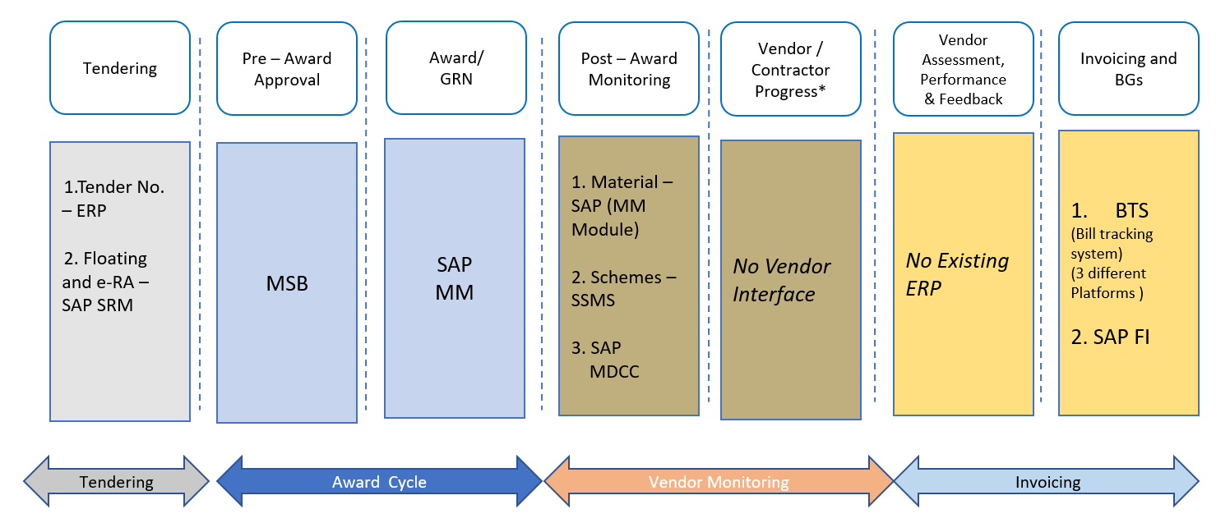

As Is Issues in IT Landscape C&M
- Various ERPs in different stages is being followed in Engineering, Procurement and Execution and do not interface with each other on common Platform.
- No single window Dashboard /reports to identify the gaps in planning & monitoring of same at the same time.
- Limited window for data accessibility for internal statutory audits

Issues remain unattended in Current IT Landscape of C&M
- Simpler user interface is required for tracking of time extension or cost escalation granted to the vendors in under various contracts
- No IT Platform available for vendor assessment and performance rating
- Intermediate milestone progress of vendors not readily available
  - Scheme – Milestone based progress
  - Material –Manufacturing Progress Report

Vendor On boarding :

This is process of discovering New suppliers, assessing their capabilities and risk checks and integrate them to our system. This will help us in identify potential buyer and better negotiation capabilities.
The on boarding process starts with either we approach the vendor doing some research online, getting recommendations from industry peers, attending trade shows etc, or vendor approaches us. From this an initial list of potential vendors are finalized and we can start reaching out to potential vendors collect the key pieces of information required to compare suppliers.

In this initiator will enter the vendor details which will trigger the mail to vendor with login ID and Password.
Vendor can log in our portal enter all the details and upload the desired document mentioning different categories for Material / services , turn over etc and complete the profile. Again initiator will check all the details and approve which will further go through pre defined approval process before vendor registration.
This all information will remain parked in the portal itself and any time we can have category wise or based on other criterion list of vendor /supplier (MIS).

Once vendor is finalized / selected for e bidding /e Auction then only vendor code is created in SRM / SAP system and that information again passed to Vendor portal to update the details like SAP Code, last PO etc along with other details.

Need Validation : This is a document in which Justification is given for Procurement of any Material or Services. It contains Budget, Justification of Requirement, Timeline etc. and goes through different approval hierarchy.
Currently this process is not in any system and taking place on Hard copy.
But application is under development stage on Non SAP platform. When it will be in use then there will be standard process / Template which will ensure uniformity across functions to create Need Validation and predefined approval Process.
Once digitized it will give the TAT (Turn Around time ) also for better monitoring and transparency which are missing currently

Current Status : Under Development (Non SAP – PHP, Backend : Laravel , Database MySQL)

MSB: This is a online Signing solution which eliminates the Manual Sign Process. This is only for Signing. A document is prepared / created and then that document e signing is used to sign that document.
Once Need Validation is done documents are uploaded in MSB and then online signing takes place as per defined Hierarchy.
Current Status: In Use (MSB)
Materials Management
SAP MM is getting used for Procurement to Pay Cycle starting from Purchase Requisition Creation – PO creation – GRN /Service Entry – Invoice verification and Payment.
Purchase Requisition (PR): Once need Validation is done and online signing is completed in MSB, Purchase Requisition is created in SAP system mentioning material codes quantity requirements, tentative unit rate and requirement date by respective user departments.. The Purchase Requisition pass through 3 level of Approval hierarchy.
Cuurent Status : In Use (SAP)
PR Tracker : The Primary Goal of PR tracking Application is to streamline and Monitor the end to end lifecycle of PR(Purchase Requisition) . All the internal and external communications related to PR need to be captured at centralized location which will help us to capture the TAT and also related users are notified for each action.
Also there should be Provision to upload the related documents / Drawing in the system for reference and reporting This will Improve visibility and efficiency across department and with vendors.
Once PR is processed in SAP system, transferred to PR tracker Application and then allocated by HOD/L1 to concerned buyers. Tracking starts starting form Floating tender to PO creation in SAP
Current Status : Under Development (Non Sap-Python)
Tendering : Tendering is Process of inviting Suppliers to Submit Offers. The tendering Process ensures the Transparency and cost effectiveness in procurement process.

In our company we invite suppliers to submit their offers for providing goods or services.
This can be
Open tender : Open to all to Submit Their Offers
Limited Tender : Restricted to limited vendors

We are doing bidding and eAuction in SAP SRM system. After bidding and eAuction once vendor is finalized (L1) we issue Purchase order in SAP. This purchase order may be to single vendor (L1) or quantity split to 2 vendors.
But Before Purchase order there is a process of further Negotiation with vendors and once price is Finalized approval note is initiated and approved outside SAP system.

Current Status : SAP SRM for eAuction but further negotiation is missing.
Purchase Order (PO): After eBidding and eAuction process and further negotiation, once Price is Finalized, Purchase order is created in SAP system with reference to approved PR mentioning Delivery date, Payment terms etc.
The PO is approved at 2 level in SAP and then given to vendor for Supply of Materials / work order.
Current Status : In Use (SAP)
Post award Monitoring : Post award monitoring is basically different Sub processes in between PO and GRN (Goods Receipt), like :
Progress Monitoring (At vendor Location) : In this we can have clear picture of different manufacturing Stages at vendor ( Raw Material procured, ready for Inspection etc) or in case of Service orders monitoring the Mile stones.
Inspection Call (by vendor) : Once material is ready inspection is done at vendor location in some cases. This may be by internal team or by Third party inspector. There should be system to track the process with TAT.
MDCC (Material Dispatch Clearance Certificate) : Once inspection is done then based on inspection result we issue the MDCC to vendor for material Dispatch.
ASN (Advance Shipping Notes) : ASN is document sent by vendor which contains detailed information about shipment and help us prepare for delivery and further helps in our preparedness and effective Inventory management.

Progress Monitoring (At vendor Location) | Not available
Inspection Call (by vendor) | Not available
MDCC (Material Dispatch Clearance Certificate) | SAP
ASN (Advance Shipping Notes) | Not available

In our System after PO in SAP there is no update of Manufacturing / Progress status. only MDCC is a process is taking Place in SAP.
Current Status : Only MDCC in Use in SAP
SSMS (Scheme Status Monitoring System) : This is a process of Quality check of any Scheme under “work In Progress” or Completed stage. In this the execution Engineer creates the inspection call for Quality check. This may be stage inspection or Final inspection.
Execution Engineer fills up the check sheet form the dropdown and with remarks and with supporting documents if any to create the inspection call. Once inspection call is created that goes to Quality team for further action. Quality team has the option to either clear the quality or return with NC remarks which will rectified and then closed.
Current Status : In Use (Non SAP - .NET Backend : C# , Database : Oracle)
Vendor assessment and Performance Feedback : There is a requirement of vendor Performance assessment based on certain predefined Criteria. Some of the criteria for compliance may be (For example only) :

Criteria | Text
1 | Mobilization & Consistency
2 | Quality
3 | Time Limit Compliance
4 | Safety Rule Compliance
5 | Legal Matter Compliance etc

In this every time a Service bill is certified (service Entry is done) then user has to enter the score against the predefined criteria (within min and Max score range) and based on score entered vendor evolution is done. This will help us in awarding Good Performing Vendors and blocking non Performing vendors for
future orders.

Current Status: Not is Use

Invoicing :
BTS : Bill Tracking System (BTS) Facilitate Vendors to Submit bills Online. Vendor submit bills in BTS system against work order awarded only. Form SAP system all work orders are transferred to BTS system and vendor submits the Bill against SAP work order number.. Once Bills are submitted with necessary prerequisite documents (HR documents Environment and Safety Documents) and then vendor support cell (VSC) team review bill details and validate supporting Documents.
The Bill is either approved or reverted back to vendor for correction with remarks. Vendor rectify the remarks and resubmit the bills.
Then approved bill moves further as per nature of bill and predefined hierarchy. There are different stages of approval and once approved at final level scrolling is done in SAP System and invoice is processed
Current Status : in Use (Non SAP .NET Backend : C Sharp , Database : Oracle)
Invoicing and Payment in SAP : Once bill is approved in BTS system, scrolling is done in SAP system and then Invoice is processed in SAP system and Payment is done.
Current Status : in Use (SAP)
Finally there should be single MIS to have integrated report at different stages once Need Validation is created in the system along with Turn around Time (TAT)

Entire Final portal will be called power procurement portal

Module 1: Vendor On boarding
[need to create fully from scratch]
Module 2: Need Validation
Under Development just need to integrate it with power procurement portal
Teck Stack: PHP, Laravel, MySQL DB

Module 3: Material management (SAP application) and PR Creation
Using SAP MM for Purchase Requisition (PR) creation, PO creation, GRN/Service entry, Invoice verification and payment
just need to integrate this with power procurement portal

Module 4: PR Tracker (Python application)
PR created in SAP passes to PR tracker HOD/L1 will assign it to buyer
For TAT, notification to User, Upload option for transparency
need to intergrate this python application with power procurement portal

Module 5: Tendering
Open / limited tender
SAP SRM for e auction is getting used but we do further negotiation on price and wont have option to change price in SAP portal
PO is created in SAP approved by 2 levels in SAP then given to vendor
need to integrate SAP SRM into power procurement portal
and need to handle final price correctly

Module 6: Post Award Monitoring
Progress monitoring at vendor location [need to develop]
Inspection call by vendor [need to develop]
MDCC [Need to integrate SAP]
ASN [Need to develop]

Module 7: SSMS [scheme status monitoring status]
Stage inspection / final inspection
Engineer will fills up check sheet [will also have upload document option]
Quality team accept or return with NC
Tech stack : C#, .Net, oracle DB
Need to integrate this with procurement portal

Module 8: Invoicing
Bill tracking system : bill against work order upload by vendor accept/revert by VSC accepted will go through hierarchy
Tech stack: C#, .Net, oracle DB
Need to integrate this with procurement portal

Module 9: Vendor Assessment & performance Feedback
Score vendor on the basis of pre-defined criteria

all connections between the modules will need to develop
for integration of NON SAP aaplication full source code of existion application will be provided

